Shah Shashwat Nimesh, Sheet 1 of 8

Shah Kruti Bhavesh, Total number of Sheets - 8

Gupta Manasvi Ganesh,

Jobanputra Khushi Dharmendra ,

Karani Ruhina,

Application Number:

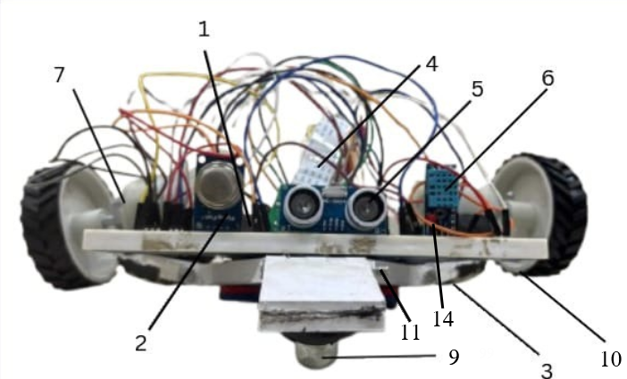

Figure 1



**Shah Shashwat Nimesh**

Applicant

Shah Shashwat Nimesh, Sheet 2 of 8

Shah Kruti Bhavesh, Total number of Sheets - 8

Gupta Manasvi Ganesh,

Jobanputra Khushi Dharmendra ,

Karani Ruhina,

Application Number:

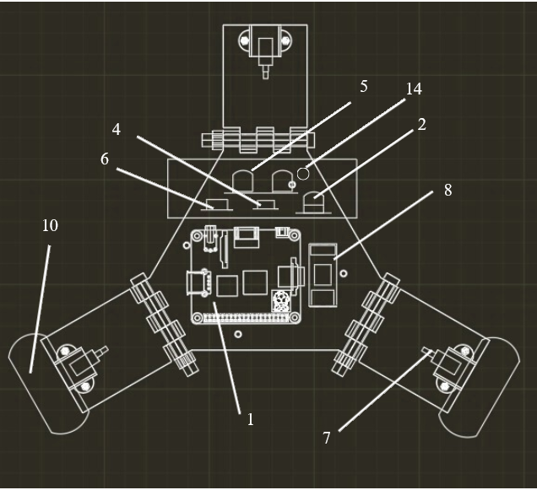

Figure 2.



**Shah Shashwat Nimesh**

Applicant

Shah Shashwat Nimesh, Sheet 3 of 8

Shah Kruti Bhavesh, Total number of Sheets - 8

Gupta Manasvi Ganesh,

Jobanputra Khushi Dharmendra ,

Karani Ruhina,

Application Number:

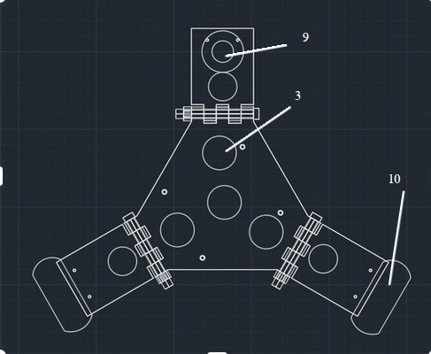Figure 3



**Shah Shashwat Nimesh**

Applicant

Shah Shashwat Nimesh, Sheet 4 of 8

Shah Kruti Bhavesh, Total number of Sheets - 8

Gupta Manasvi Ganesh,

Jobanputra Khushi Dharmendra ,

Karani Ruhina,

Application Number

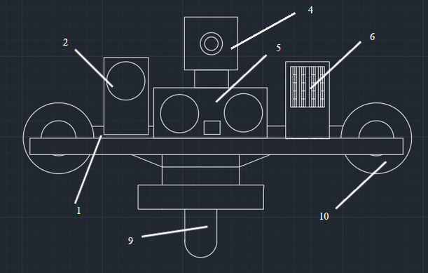Figure 4



**Shah Shashwat Nimesh**

Applicant

Shah Shashwat Nimesh, Sheet 5 of 8

Shah Kruti Bhavesh, Total number of Sheets - 8

Gupta Manasvi Ganesh,

Jobanputra Khushi Dharmendra ,

Karani Ruhina,

Application Number

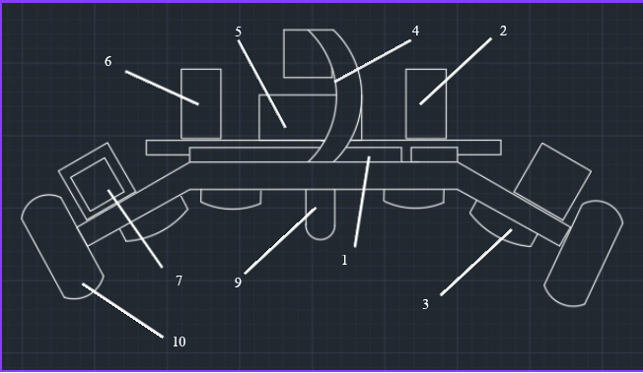Figure 5

**Shah Shashwat Nimesh**

Applicant

Shah Shashwat Nimesh, Sheet 6 of 8

Shah Kruti Bhavesh, Total number of Sheets - 8

Gupta Manasvi Ganesh,

Jobanputra Khushi Dharmendra ,

Karani Ruhina,

Application Number

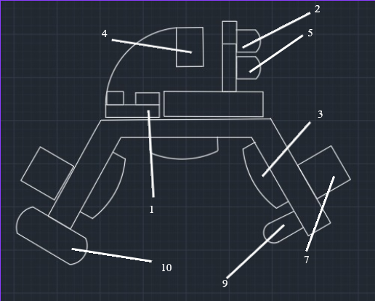

Figure 6

 **Shah Shashwat Nimesh**

Applicant

Shah Shashwat Nimesh, Sheet 7 of 8

Shah Kruti Bhavesh, Total number of Sheets - 8

Gupta Manasvi Ganesh,

Jobanputra Khushi Dharmendra ,

Karani Ruhina,

Application Number

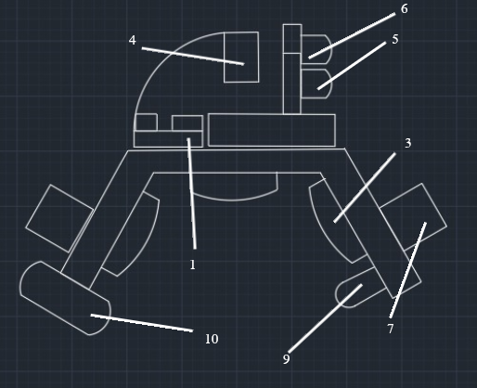

Figure 7

 **Shah Shashwat Nimesh**

Applicant

Shah Shashwat Nimesh, Sheet 8 of 8

Shah Kruti Bhavesh, Total number of Sheets - 8

Gupta Manasvi Ganesh,

Jobanputra Khushi Dharmendra ,

Karani Ruhina,

Application Number

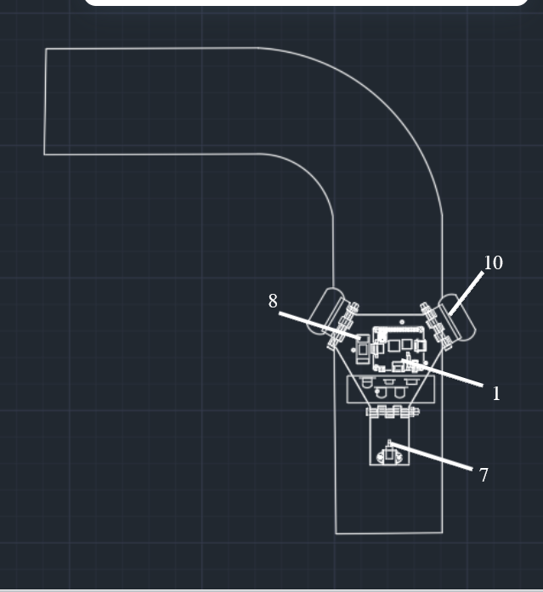

Figure 8

 **Shah Shashwat Nimesh**

Applicant